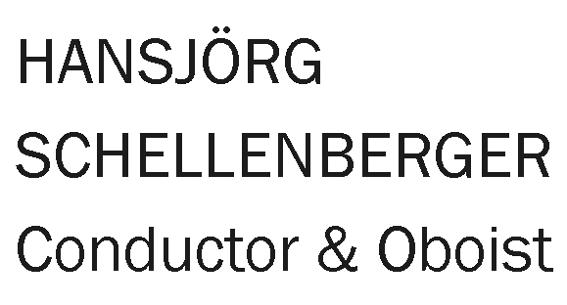

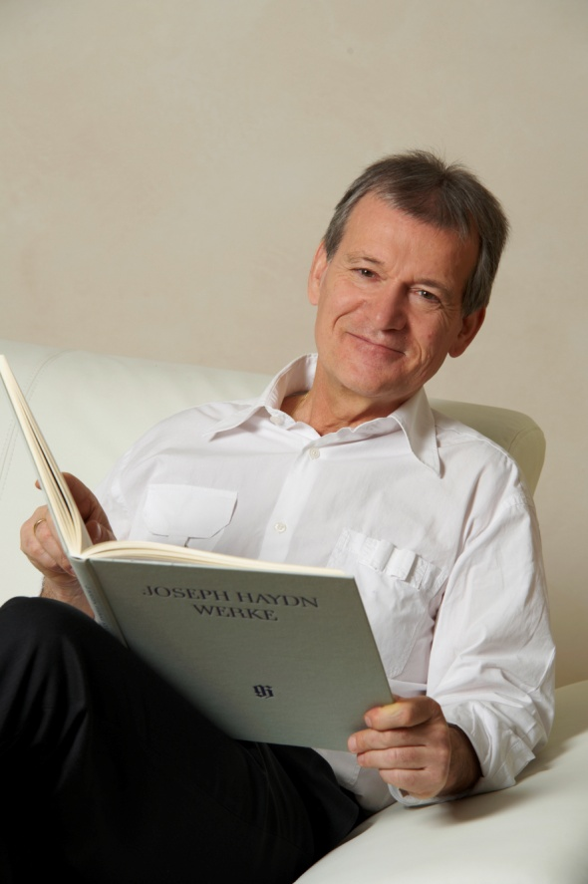
In the course of a long international career embracing several different fields of musical activity, Hansjörg Schellenberger has made a well-respected name for himself as an excellent solo oboist with the Berlin Philharmonic, as founder of an ensemble, as a conductor with wide orchestral experience, and as a deeply committed teacher.
The legendary Jan Koetsier instructed him in the use of the baton while Schellenberger - who was incidentally also an academic mathematician - was studying what was to become the focus of his attention with Manfred Clement. Thus it happened that he was never just an oboist. Decades of observing, scrutinising scores and comparing interpretations at first hand on the podium or in the orchestra pit all combined to form the basis of a second career that has now extended into the international sphere.
Amongst the many high-quality orchestras which regularly welcome Schellenberger on to their rostrums are the Camerata Salzburg, the Spanish National Orchestra, the Orchestra Verdi of Milan, the Orchestra della Svizzera italiana and the German Radio Philharmonic of Saarbrücken-Kaiserslautern.
Schellenberger conducted the Munich Radio Orchestra in an excellent performance of Haydn's La fedeltà delusa to celebrate its composer's bicentenary. The Süddeutsche Zeitung wrote: "The conductor, Hansjörg Schellenberger, drew some transparent and delicate playing from the Munich Radio Orchestra."
After the tour of Japan, which Hansjörg Schellenberger has completed in 2012 with the pianist Yu Kosuge and the Camerata Salzburg, the Okayama Philharmonic Orchestra took the opportunity to nominate the tour's "musical director" as its chief conductor. This contract, recently extended until 2022, offers him not only the opportunity to improve the orchestra further but also to continue to develop the local musical scene and work with young people.

Since 2000 he has had a small and very select oboe class at Europe's only purely privately-run school of music, the Escuela Superior de Musica Reina Sofia in Madrid, where he also teaches the chamber music classes for the wind players of the school's International Institute for Chamber Music. This arrangement comes under the patronage of the Queen of Spain and is supported by the Fundación Albéniz, which was founded by Paloma O'Shea, one of Spain's most influential women.
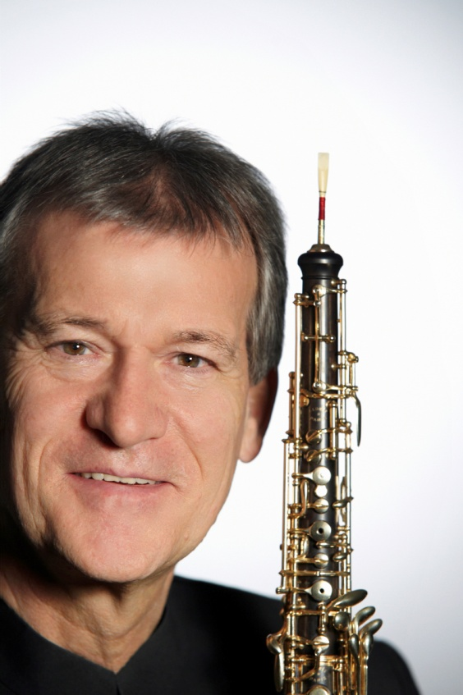
Hansjörg Schellenberger's cooperation with his wife, the excellent harpist Margit-Anna Süß, in chamber performances and on the concert stage is also of central artistic importance to him. For more than twenty years this "family business" has formed a very sought-after duo and has acquainted music fans at countless German performance venues and on many international tours with special repertoire gems. In the last years several concerto tours took them to Japan.
The artist has demonstrated his work as a musician on more than fifty CDs with all the major recording firms. Moreover, ten years ago he founded his own label, Campanella Musica, on which he himself is represented with works by composers such as Carl Philipp Emanuel Bach, Joseph Haydn, and Ludwig van Beethoven as well as with a French baroque program and various works by modern classical composers.
Hansjörg Schellenberger and his wife Margit-Anna Süß live in the Chiemgau Alps with their four children.

Further Information:
www.hansjoerg-schellenberger.com

